DJANGO INSTALLATION

1. To install django at first we need to install python

2. Download python from official website

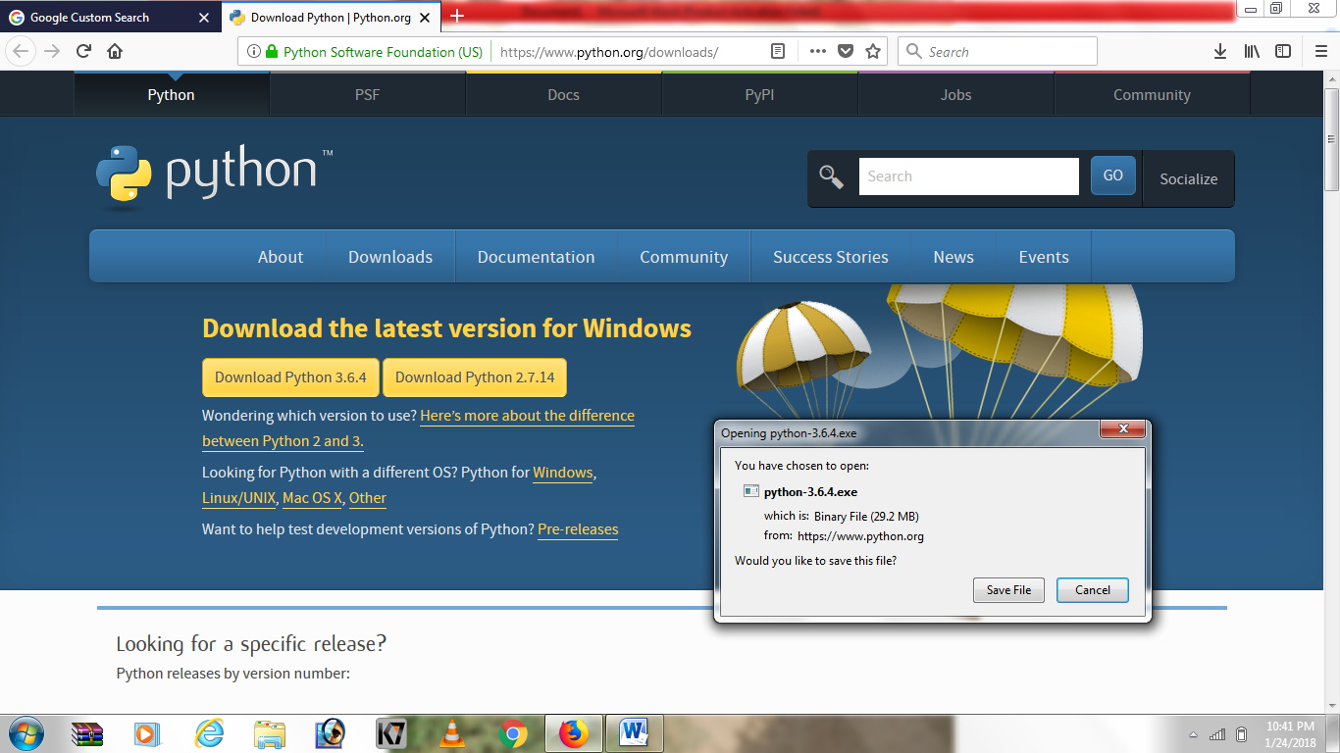

3. Open the python exe file as administrator from downloads

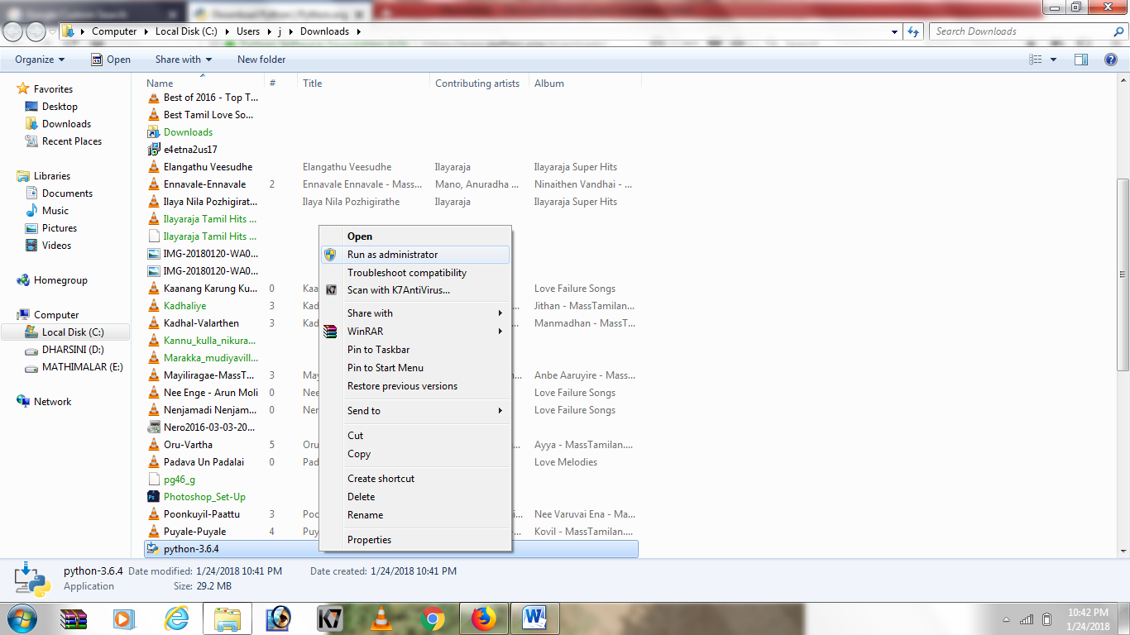

4. After running python as administrator, choose customize installation

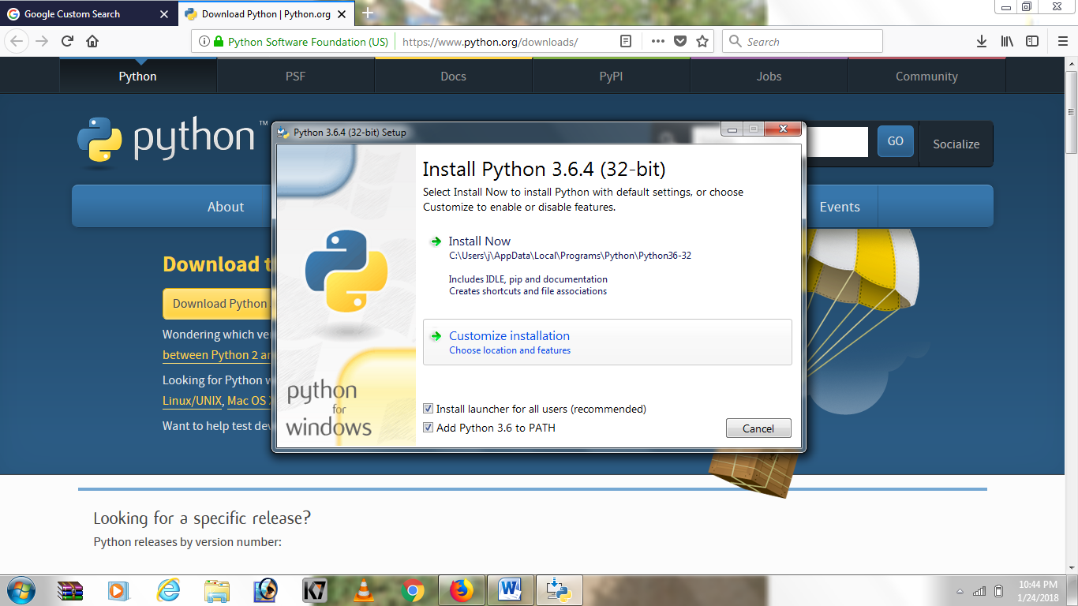

5. Follow these steps

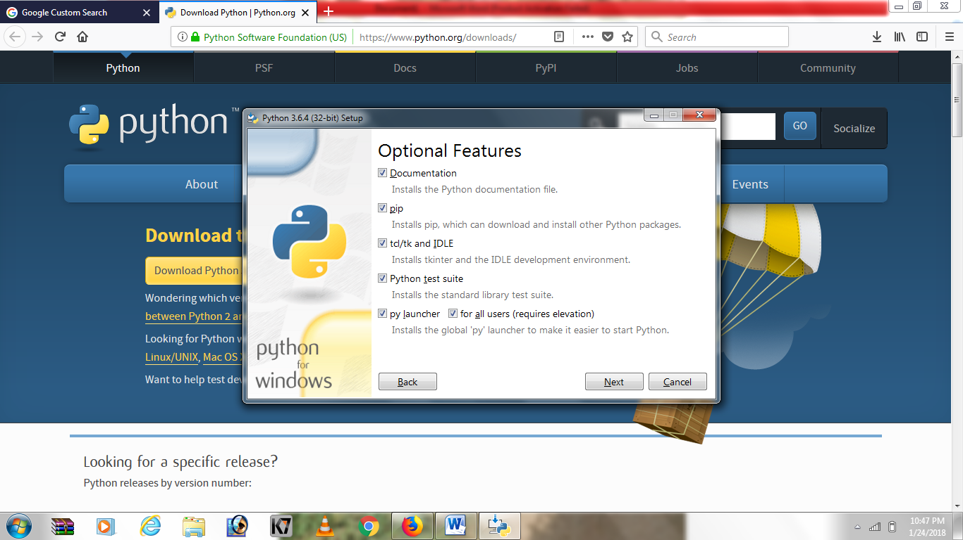

6.Select the path to install python and click install

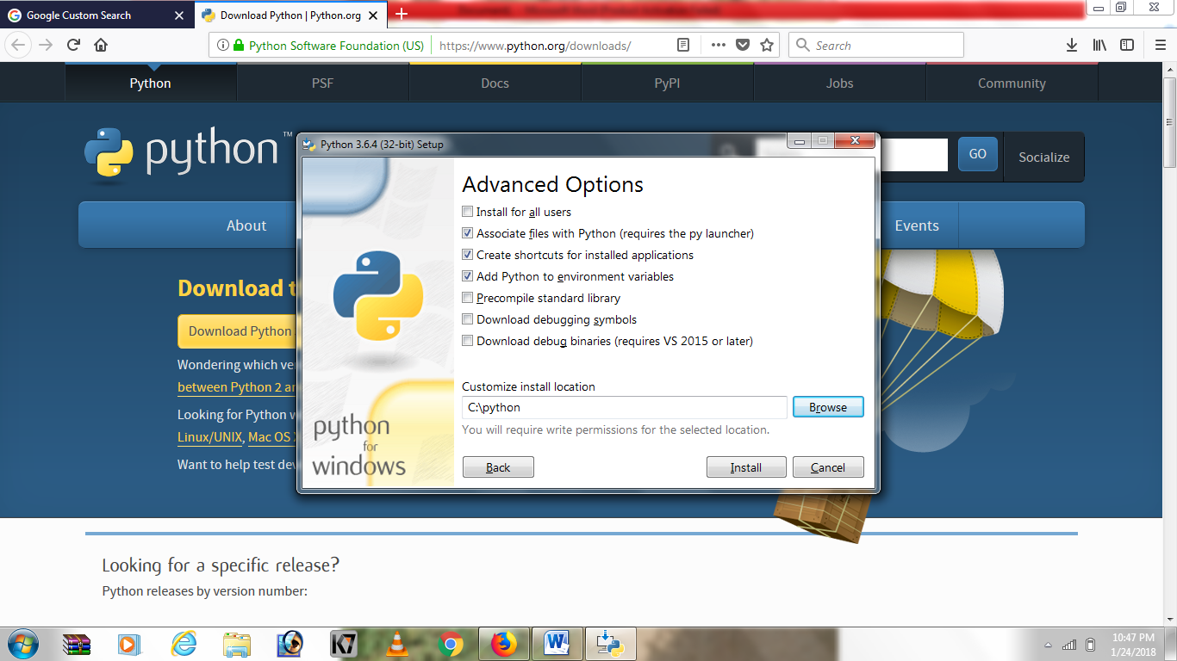

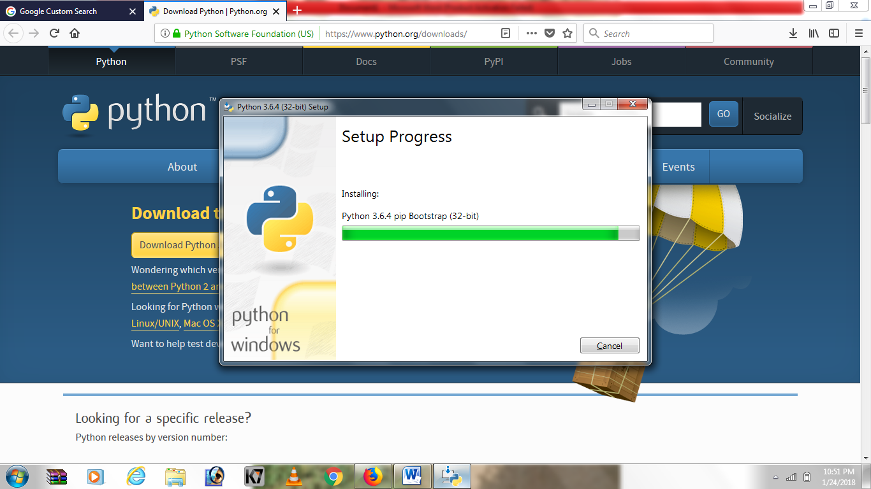

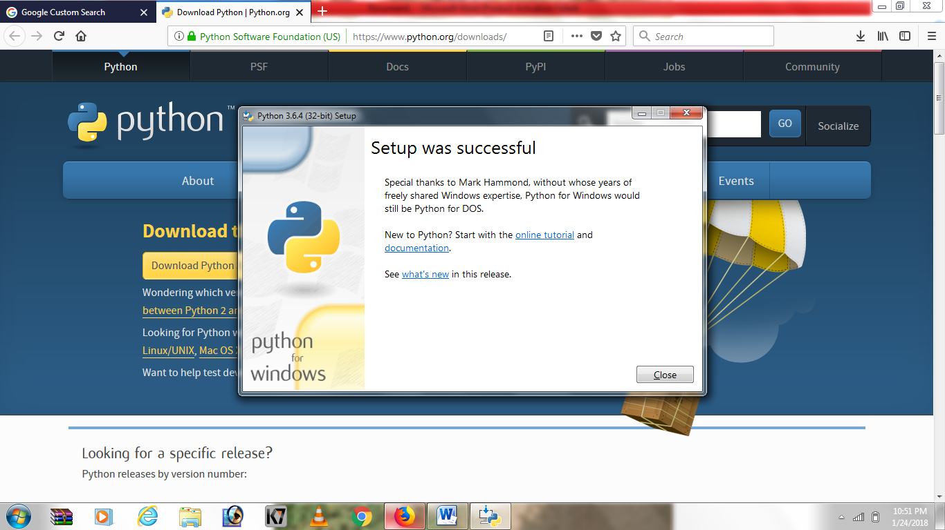

7.after installing python open the command prompt as administrator

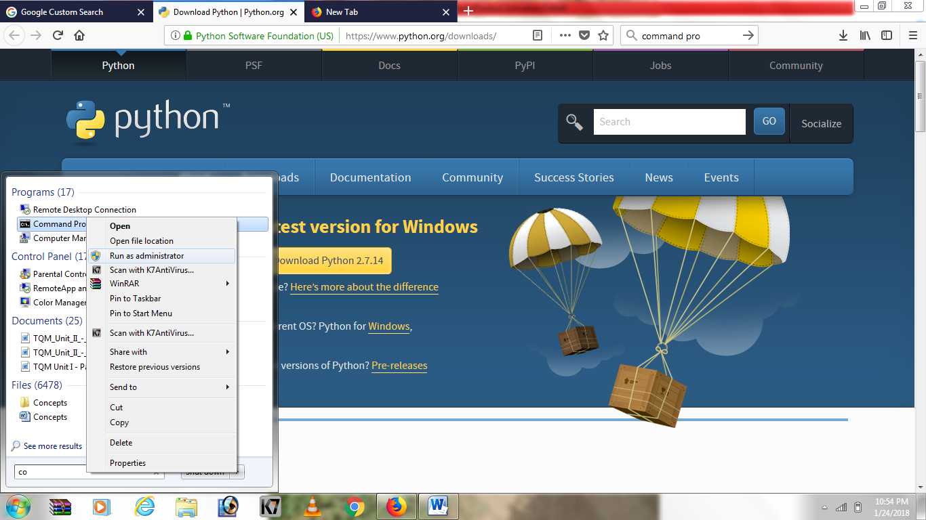

8. And type python –version ,it will show the python version that we installed

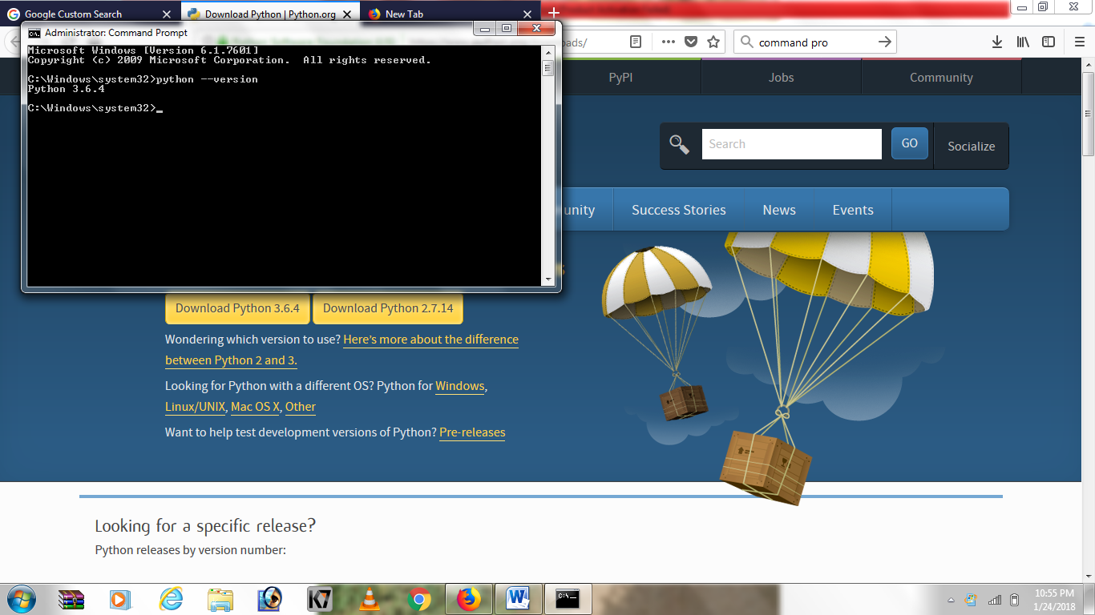

9.After that type “pip install django==1.9”(if we need specify the version or it will install the lastest version)

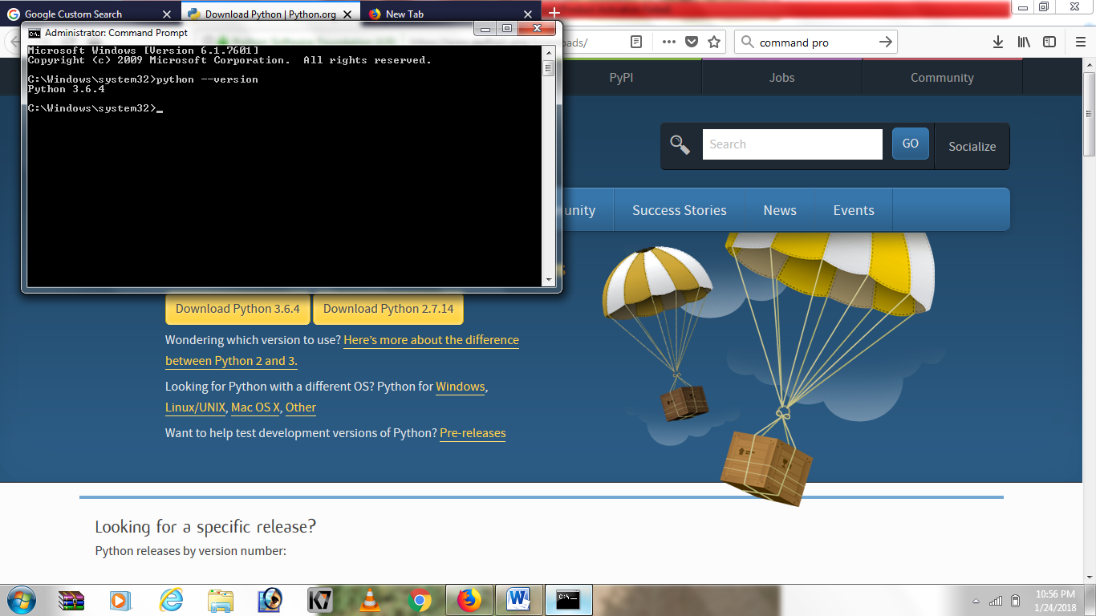

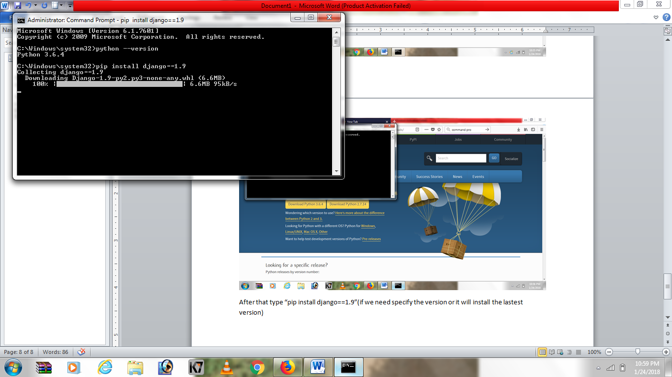

10.You will get a msg that django installed sucessfully

